
WAYNE CENTRAL SCHOOL DISTRICT
BOARD OF EDUCATION MEETING AGENDA

December 6, 2007 6:30 p.m. Ontario Elementary South Gym

6:30 Tour of Ontario Elementary School

7:00 Call to Order
Pledge of Allegiance
7:05 Approval of Agenda/Approval of Minutes Att. 1

7:10 Public Comment
7:15 Board Member Comments
7:20 Board President Comments

7:25 Action Item

7:30 Superintendent’s Report
- Elementary School Improvement Plan Presentation
- First Quarter Academic Report Att. 2
- Review Budget Calendar Att. 3
- Background Check
- Financial Update
- Student Representative
- Student Questions

9:00 Board Action
- Approve Personnel Action Att. 4
- Approve CSE/CPSE Action Att. 5
- Consensus Agenda: Att. 6
1. Approve Treasurer’s Reports
2. Approve Surplus Property Designation
3. Accept Gift to the District
4. Award BOCES Coop Bid
5. Accept Audit Report

9:15 Policy Att. 7

9:30 Public Comment
8:10 Board Member Comments
8:15 Adjournment

Next Meeting Date: January 10, 2007 7:00 p.m. Freewill Elementary School

District Mission Statement

Based on the belief that all students can learn, the staff of the Wayne Central School District accepts the responsibility to teach all students, regardless of differences, the fundamental skills. We further accept the responsibility to challenge all students to attain higher levels of achievement. Wayne Central will provide the opportunity, environment, and encouragement to meet this goal

while developing the whole child, physically, socially, emotionally, and culturally.
Att. 1

WAYNE CENTRAL SCHOOL DISTRICT
Ontario Center, New York 14520

BOARD OF EDUCATION MINUTES UNOFFICIAL UNTIL APPROVED

DATE: Thursday, November 15 2007 TIME: 6:00 p.m.
TYPE: Regular Business Meeting PLACE: Middle School Library

PRESENT: Trustees Johnson, Lyke, Newman, Nicholson, Robusto, Schultz (arrived @ 6;32 p.m.), Triou (arrived @ 6:30 p.m.); District Clerk Switzer; Administrators Havens, Armitage, Armocida,, Pullen, Schiek, Atseff, Cox, Callahan, Miller, Prince, Green

ABSENT: Trustees Griswold & Wyse

GUESTS: Visitor’s Roster filed in clerk’s agenda file, this meeting

I. CALL TO ORDER: 6:00 p.m. by Frank Robusto, Jr., School Board President

II. EXECUTIVE SESSION (Student Matters)

Mrs. Newman offered a MOTION, seconded by Mr. Johnson, to adjourn the meeting, at 6:05 p.m., for an executive session on matters pertaining to specific students. 5 Ayes, 0 Nays, 4 Absent (Mr. Griswold, Mr. Schultz, Mr. Triou, Mr. Wyse), Carried.

(Mr. Triou entered the meeting @ 6:30 p.m.)

(Mr. Schultz entered the meeting @ 6:32 p.m.)

III. RECONVENE: 7:02 p.m.

Prior to start of the business meeting, trustees and school personnel conducted a tour of the building to fulfill the requirement of §1705 of the Education Law for annual building visits.

IV. PLEDGE OF ALLEGIANCE

V. APPROVAL OF AGENDA & MINUTES (October 25 & November 1, 2007)

Mr. Robusto presented consideration of an appeal of the decision of the superintendent of schools on a student matter as an additional agenda item. Mr. Triou offered a MOTION, seconded by Mrs. Lyke, to approve the agenda for this evening’s meeting, as revised, and the minutes of the meetings of October 25 & November 1, 2007, both as presented. 7 Ayes, 0 Nays, 2 Absent (Mr. Griswold, Mr. Wyse) Carried.

VI. PUBLIC COMMENT – None
.
VII. BOARD MEMBER COMMENTS

- Mr. Triou complimented the high school for the awesome career day and noted that he was pleased to have a chance to serve as a resource person on computers in the workplace.

- Mr. Triou stated that he enjoyed speaking to the first grade classes at Freewill Elementary School about the role of a school board members; the most frequent question from students was why school board members have no role in deciding when to declare snow days.

VIII. BOARD PRESIDENT’S COMMENTS

- Mr. Robusto added his compliments to the high school on career day, including the visit by Lou Gramm, and noted the participation of volunteers and service groups, including the Interact Club.

- Mr. Robusto extended condolences to the family of Lawrence Wojcik, a vocational math teacher at the high school in the 1960’s, who was recently featured in Gannett Rochester Newspapers for his numerous contributions to areas schools, including Edison Technical & Industrial High School in the Rochester City School District, and his sacrifices during 14 months in a German P.O.W. camp during World War II.

IX. REPORT ON ACTION ITEMS BY THE SUPERINTENDENT OF SCHOOLS

A. Mr. Havens noted he had provided written reply to a resident’s question at the prior meeting to advise that international baccalaureate training will include special education teachers.

X. REPORTS OF THE SUPERINTENDENT OF SCHOOLS

- RECOGNTION OF TRUSTEE TRAINING & ACHIEVEMENT

Mr. Havens presented a certificate from the NYS School Boards Association to Mrs. Newman in recognition of 40 credits in school board training.

- AMERICAN EDUCATION WEEK PROCLAMATION

Mr. Havens presented a proclamation in observance of American Education Week, TO WIT:

PROCLAMATION IN OBSERVANCE OF
AMERICAN EDUCATION WEEK • 1007
(November 11-17)

WHEREAS, public schools are the backbone of our democracy, providing young people with the tools they need to maintain our nation's precious values of freedom, civility and equality; and

WHEREAS, by equipping young Americans with both practical skills and broader intellectual abilities, schools give them hope for, and access to, a productive future; and

WHEREAS, education employees - be they custodians or teachers, bus drivers or librarians – work tirelessly to serve our children and communities with care and professionalism; and

WHEREAS, schools are community linchpins, bringing together adults and children, educators and volunteers, business leaders, and elected officials in a common enterprise;

NOW, THEREFORE, I, Michael L. Havens, superintendent of schools of the Wayne Central School District, do hereby proclaim November 11-17, 2007 as the 86th annual observance of American Education Week

Mr. Havens added his personal thanks and appreciation to each of the some 450 persons who make local schools a special place for children to learn and educators to work each day.

C. PROGRESS REPORT ON SCHOOL IMPROVEMENT PLAN • FACILITIES AND FINANCE

Mr. Havens presented the facilities and finance sections of the school improvement plan for 2007 for facilities and finance for review and information of trustees.

Mr. Atseff, assistant superintendent for business, Mr. Miller, director of facilities, and Mr. Prince, director of transportation, reviewed a Power Point presentation on items as follows:

• Maintain superior, clean and inviting facilities,
• final scope for capital project for additional classroom space adjacent to Ontario Primary School
• voter approval of the proposed 2008-2009 budget by a favorable margin of 65% or greater
(copy filed in clerk’s agenda file, this meeting)

In the area of superior, clean and inviting facilities for our students, Mr. Atseff noted that maintenance and updates to facilities provide the foundation to meet instructional goals and keep costs down. He added that top-notch facilities insure a safe environment which produces high quality learning to prepare students to compete in the global economy and the community takes pride in school facilities as evidenced by support of capital improvements.

Mr. Atseff shared photos of areas for repairs and improvements, then and now, from 2001 to 2007, in the following areas;

HIGH SCHOOL: dining room, outdoor signage, TV production and broadcasting, fitness and weight training, science and technology classrooms & corridor floor surfaces

MIDDLE SCHOOL: curbs & sidewalks, outdoor signage, cafetorium/dining area, corridor floor surfaces, security and entry areas, access by persons with disabilities

ONTARIO ELEMENTARY SCHOOL: Entry steps and railings, corridor floor surfaces, lift to gym

ONTARIO PRIMARY SCHOOL: Renovation of classroom bathrooms, passive restraint security and entry foyer, music classroom, staff room & cafetorium floor surfaces and ceiling painting

FREEWILL ELEMENTARY SCHOOL: security and entry areas, corridor floor and ceiling surfaces, common tile areas in classroom areas

Mr. Schultz noted compliments by visiting team athletes and parents about the excellent weight training and fitness centers.

With regard to the scope for capital project, Mr. Miller noted that the architect is developing concept drawings and cost estimates for construction of new classroom pace adjacent to Ontario Primary School which would allow use of Ontario Elementary School as a district education center.
Mr. Atseff noted that preliminary discussions by the architect with the NYS Education Department indicate strict interpretation of guidelines for classroom capacity of twenty-seven (27) students which translates to six (6) new classrooms to meet the student enrollment in grades K to 5 at Ontario Primary School and Ontario Elementary School. He stated that school personnel, the architect and the construction management firm are reviewing alternative space uses related to classroom capacity.
Mr. Schultz asked for clarification of the state regulations on classroom capacity. Mr. Havens noted that the initial review by the architect highlighted state guidelines on standard classroom space. He explained that uses such as universal pre-kindergarten programs are not included in those guidelines and provide options to increase the number of approved classrooms.
Mr. Johnson asked if this interpretation indicates that the NYS Education Department wishes school districts to build new space rather than make renovations.
Mr. Nicholson asked if the 27-student guideline is the same for new and renovated space; the answer was yes.
Mr. Triou noted that construction of new space with less capacity is possible but would not yield state aid.
Mr. Schultz noted substantial variance between local and state class sizes guidelines.
Mrs. Lyke noted that recent discussions at the Four County School Boards Association by Geneva City School District on state and local class size variances. Efforts are underway with state school boards’ association staff members to illustrate local needs versus state guidelines to state officials and legislators.
Mr. Triou asked when trustees might see preliminary sketches: Mr. Atseff stated January, 2008.
Mr. Prince, director of transportation, reviewed the goal for passage of the proposed budget by a favorable margin of 65% or greater and no more than 35% with a no vote.. He noted that budget approval is an indicator of the community’s support of the direction and leadership of the school district and provides the resources and environment necessary to create successful programs.
Mr. Triou asked if the traditional budget presentations to civic and community groups and staff members are planned again; Mr. Havens stated they were.
Mrs. Newman suggested incorporating the “then and now” photos presented this evening in community presentations, at community locations, on the web site and cable TV to share the progress and improvements which have occurred in the past 5 to 7 years. She added that the photos of former and present equipment and vehicles included at the visits prior to the last meeting would also provide insight.
Mr. Johnson suggested including photos of the track and athletic field updates as well.
Trustees thanked Mr. Atseff, Mr. Miller and FP for their presentations.
D. PROGRESS REPOR • TEACHER RESOURCE CENTER

Mr. Havens presented a progress report on the district’s teacher center for review and information of trustees.

Mrs. Cox, assistant superintendent for instruction, introduced Mrs. Barbara Heald, teacher center director, who reviewed a Power Point presentation and video tour on the origins and status of the teacher resource center (copy filed in clerk’s agenda file, this meeting)

Mrs. Heald outlined staff training efforts and classroom resources provided by the district’s teacher resource center which is now located on the first floor, near the main entrance, at the middle school. She shared examples of activities, resources and materials provided by and at the teacher center.

Mrs. Lyke noted the wonderful services illustrated by the presentation and compared them to the years when she served as the district teacher’s representative to the regional teacher center which provided resources on a converted school bus that visited component districts.

Mr. Havens thanked Mrs. Heald for her presentation which was acknowledged by a round of applause.

E. STATUS REPORT • LOCATION OF COMMENCEMENT EXERCISES • CLASS OF 2008

Mr. Havens presented a status report on the location of commencement exercises for the Class of 2008 for review and information of trustees.

Mrs. Holly Armitage, an assistant principal at the high school, noted that the Constellation Performing Arts Center @ Finger Lakes Community College was confirmed for the event as soon as commencement for the Class of 2007 was completed. When she sought verification of the date in September, she learned that the Rochester Broadway Theatre League (RBTL) was not longer managing the facility and tht the reservation for Friday, June 27, 2008 was cancelled.

Mrs. Armitage reported that efforts to confirm an alternate location were pursued and the event is now set for Thursday, June 26, 2008 at the Rochester Riverside Convention Center. She is working with Mrs. Lisa Marlowe, senior class advisor, and senior class officers on plans for the new venue. She has had personal experience with the site for commencement for another district.

Mrs. Lyke asked how many persons traditionally attend commencement exercises and how the change in venue might impact attendance. Mrs. Armitage stated more than 1,000 persons usually attend commencement exercises and efforts will occur to provide opportunities for as many persons to attend as may wish. She added that efforts to confirm the FLCC site for the Class of 2009 were attempted but reservations are not accepted for events beyond 18 months.

Mr. Johnson asked when notification to parents will occur. Mrs. Armitage stated the high school will sent letters to parents in the next week.

Mr. Robusto stated that he has attended events at the convention center which included free parking. Mrs. Armitage stated that she will explore that option.

Mrs. Lyke suggested consideration of school busses as shuttle busses as well.

Mr. Havens noted that many parents and residents have attended events at the convention center in the past and are acquainted with the location and parking.

Mr. Havens extended thanks to Mrs. Armitage for her efforts to confirm the alternative site with so many schools unexpectedly seeking alternative sites when their plans were cancelled.

F. FINANCIAL AND BUDGET UPDATE

Mr. Havens introduced Mr. Atseff to present monthly financial reports for review and consideration by the Board of Education.

Mr. Atseff presented reports and information through October 31st as follows: (copies filed in clerk’s agenda file, this meeting)

- Revenue Status Report– General Fund: Reflects revenues compared to revenue appropriations for 64% of budgeted revenues have arrived.

- Expense Status Report – General Fund: 25% of the general fund allocations spent to date; appropriations in good shape.

G. PAPERLESS AGENDA MATERIALS FOR SCHOOL BOARD MEETINGS

Mr. Havens asked the pleasure of trustees to continue with the paperless agenda materials for school board meetings. By consensus, the decision was to continue the paperless approach with note of the paper and postage which it has and will save.

In addition, trustees endorsed use of electronic means to transmit supplemental materials from the superintendent of schools with provisions that document security is protected.

H. COMMENTS BY STUDENT REPRESENTATIVE

Dyan VerSchage, sophomore class president, reviewed current and future student achievements and events at the high school and activities of the sophomore class.

I. STUDENT QUESTIONS

- Jeff Korff, 7603 Roder Parkway, Ontario, asked how far in advance planning starts for capital projects. Mr. Havens provided details.

XI. RECESS: 8:05 p.m.

XII. RECONVENE: 8:20 p.m.

XIII. ITEMS FOR BOARD OF EDUCATION ACTION

A. APPEAL OF STUDENT SUSPENSION BY THE SUPERINTENDENT OF SCHOOLS

Mrs. Lyke offered a MOTION, seconded by Mr. Johnson, to uphold the decision of the superintendent of schools on the long-term suspension of a specific student. 6 Ayes, 0 Nays, 2 Absent (Mr. Griswold, Mr. Schultz), 1 Abstention (Mr. Triou), Carried.

- ADDITIONAL PUBLIC COMMENT – None

XV. ADDITIONAL BOARD MEMBER COMMENTS

- Mr. Johnson complimented speakers for their informational and visual presentations this evening, noting the dramatic improvements in facilities in the 2001 to 2007 photo comparisons.

- Mrs. Newman suggested that the Board of Education commend staff members for their many contributions as part of American Education Week observance. By consensus, Mrs. Newman was authorized to work with district office staff to develop a message for distribution and display in all schools and the transportation and maintenance centers.

- Mr. Schultz noted the successful guitar hero event sponsored by the key club at the high school and that he enjoyed helping the high school parent group provide refreshments

XVI. ADJOURNMENT

Mr. Triou offered a MOTION, seconded by Mrs. Newman to adjourn the meeting at 8:23 p.m. 7 Ayes, 0 Nays, 2 Absent (Mr. Griswold, Mr. Schultz), Carried.

Respectfully submitted,

JAMES E. SWITZER
School District Clerk

APPROVAL OF MINUTES

The foregoing minutes of the Board of
Education were submitted for review
& (approved as presented)(corrected
as noted) at the meeting of

December 6, 2007

---------------------------
School District Clerk
JES/jes:wp

Att. 2

Wayne Central School District

Office of the Superintendent of Schools

Memorandum

TO: Board of Education, Michael Havens, Superintendent

FROM: Kim Cox, Assistant Superintendent for Instruction
RE: 1st Quarter Report
DATE: Nov. 29, 2007

Attached please find the Quarterly Report for the first quarter of the 2007-2008 school year. This PowerPoint includes report card data for ELA and Math in grades K-5, as well as the results for the four core areas; English, Math, Science and History, in grades 6-12. This information will be presented to you at the Dec. 6th Board of Education meeting.

If you have any questions about any of the information prior to this presentation, please feel free to contact me.

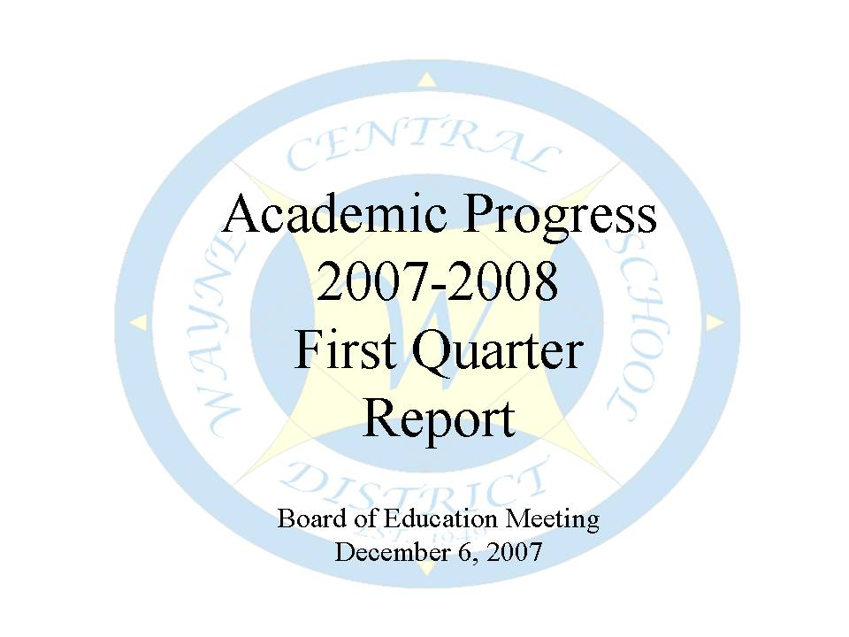

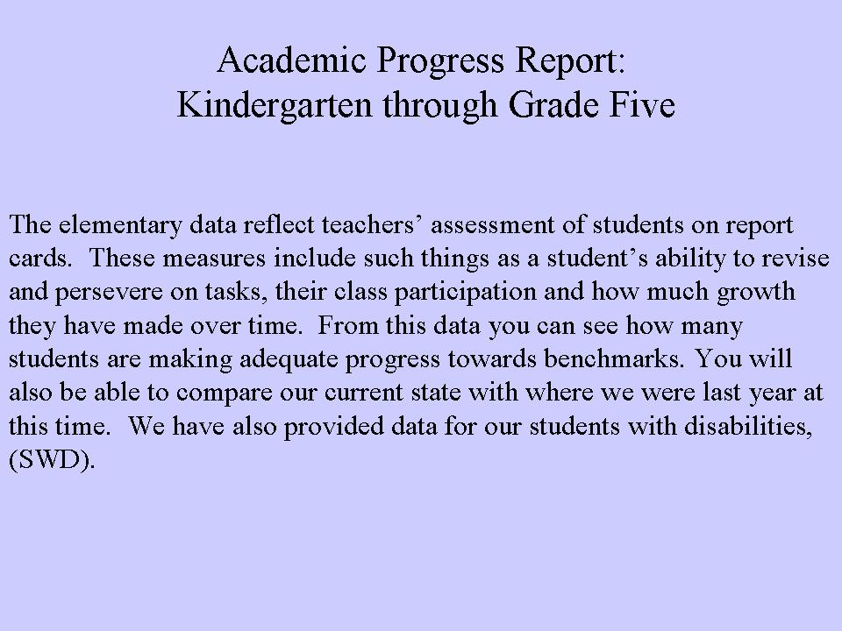

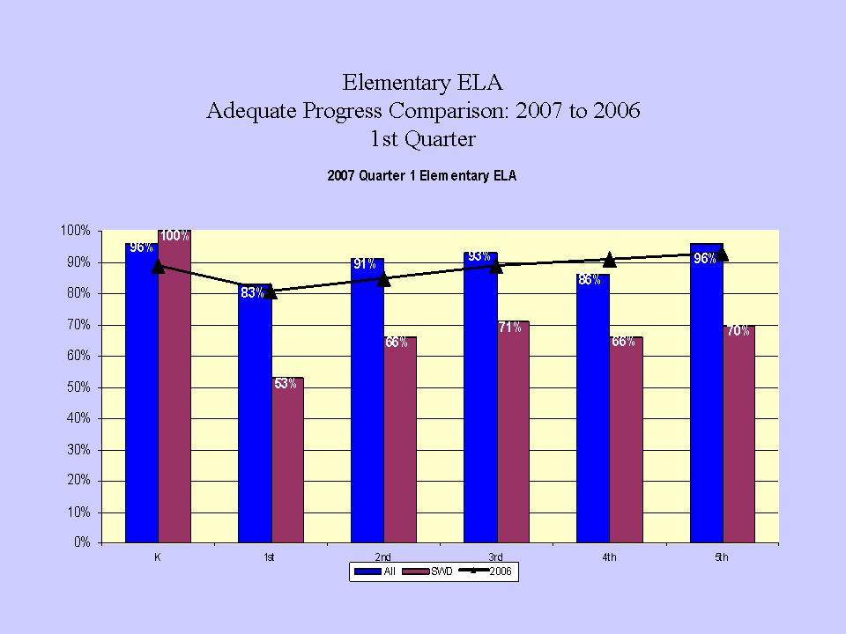

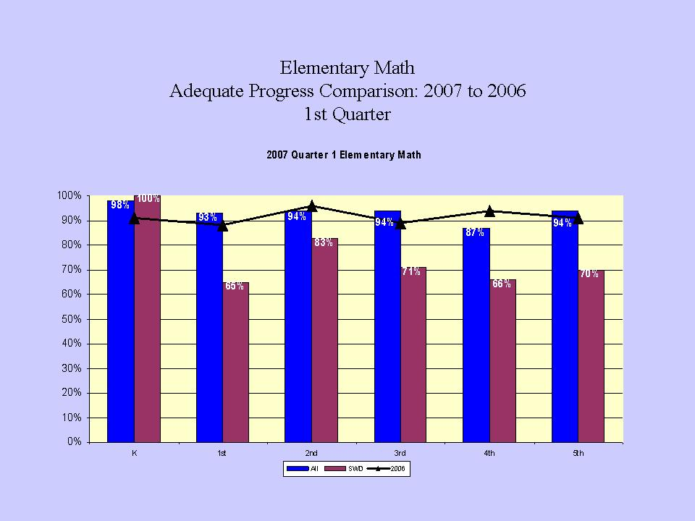

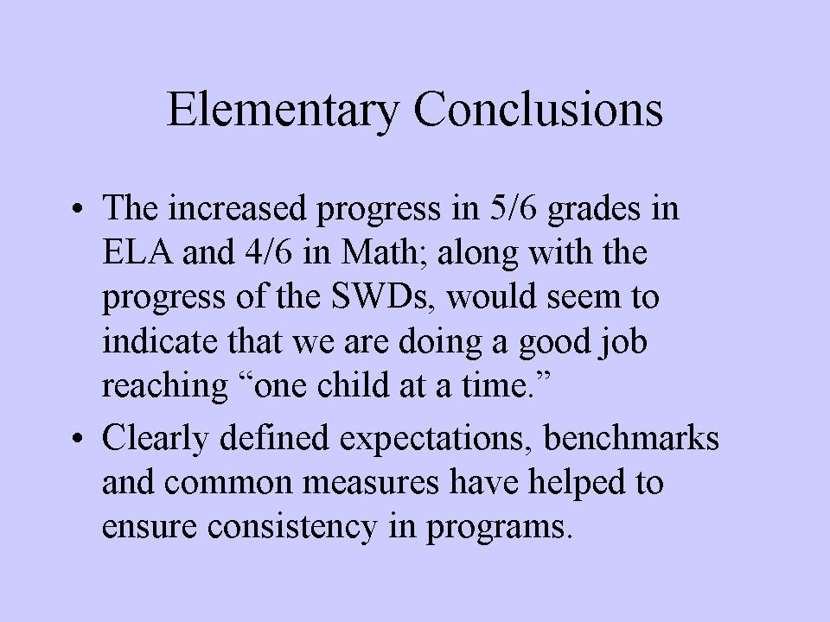

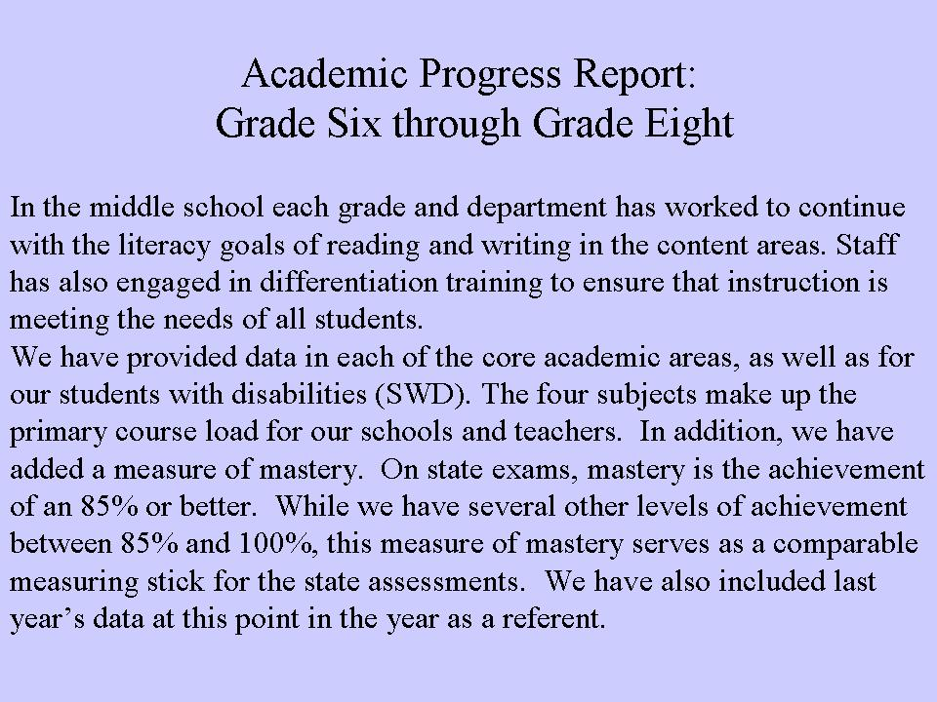

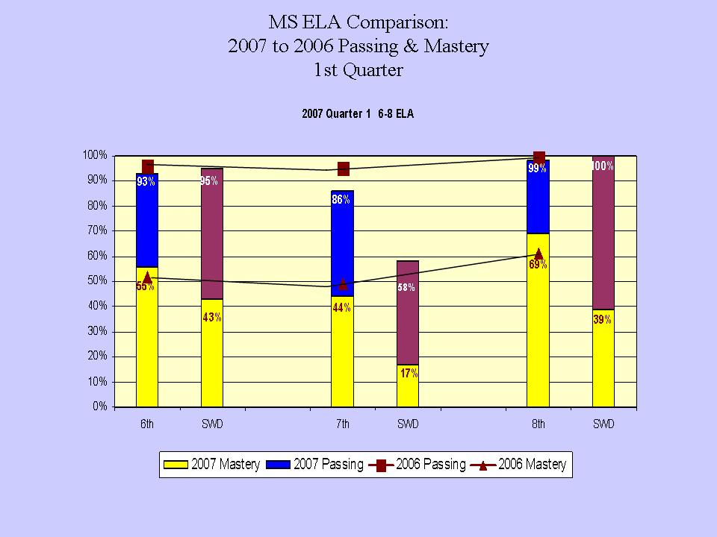

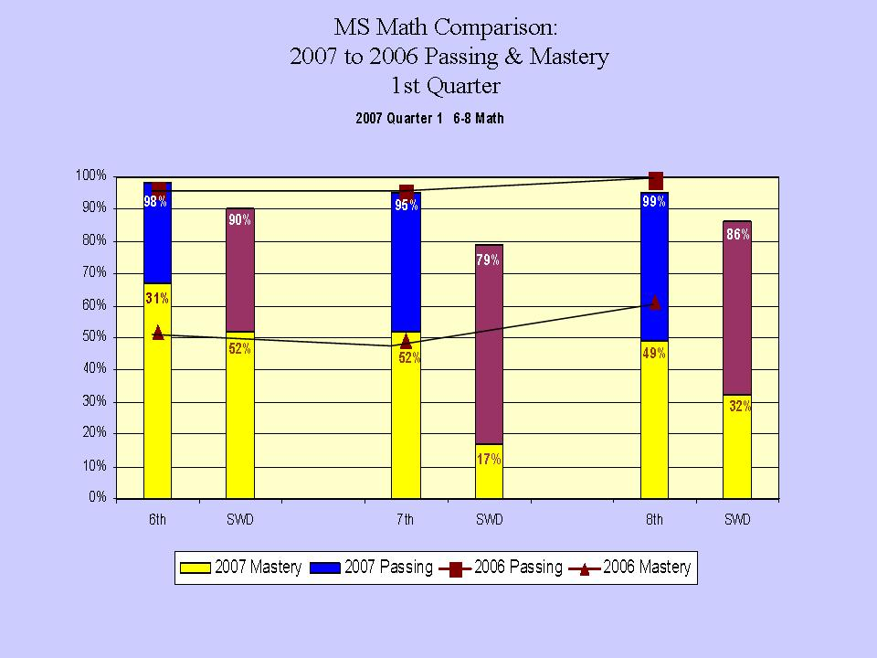

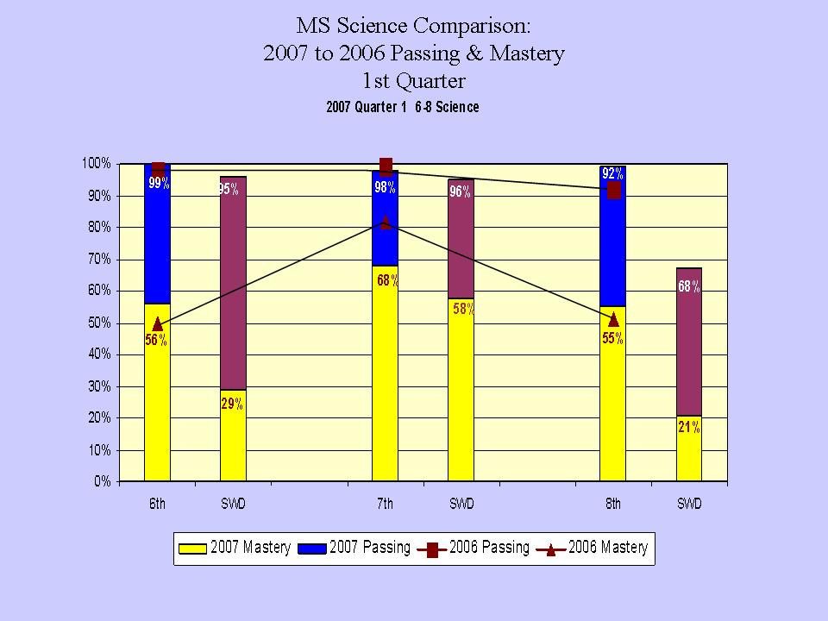

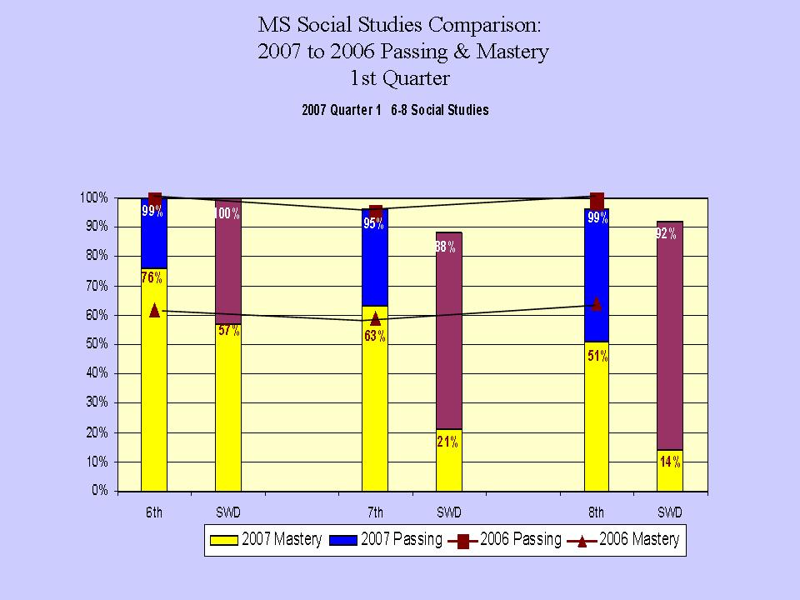

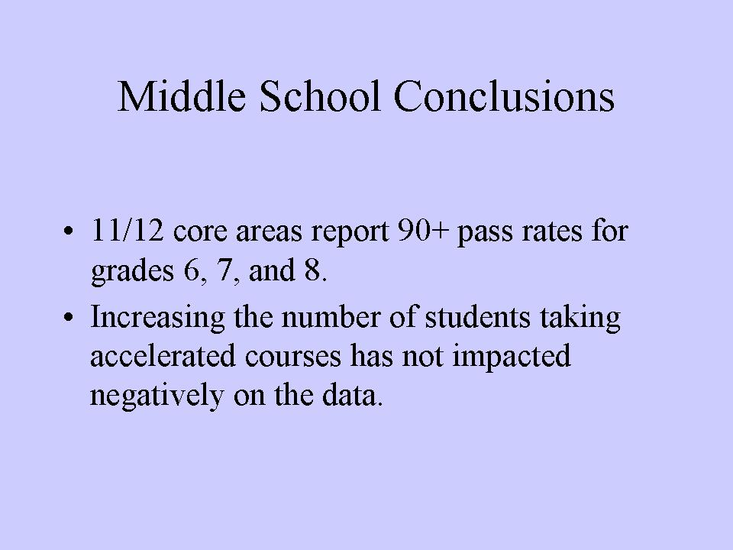

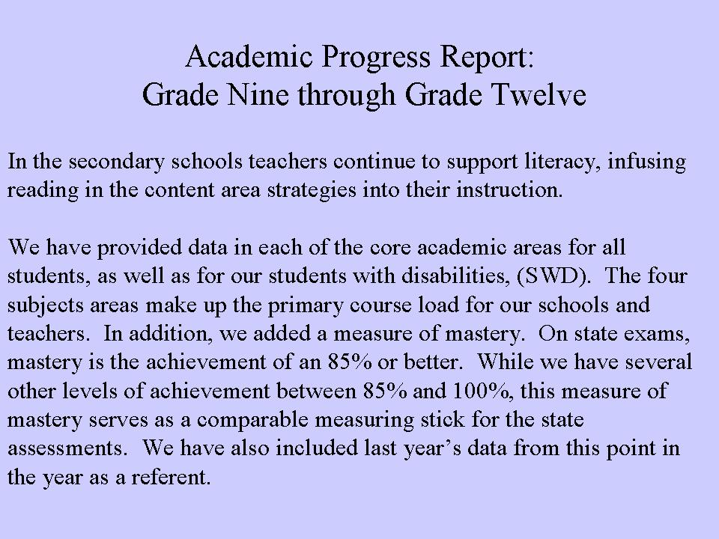

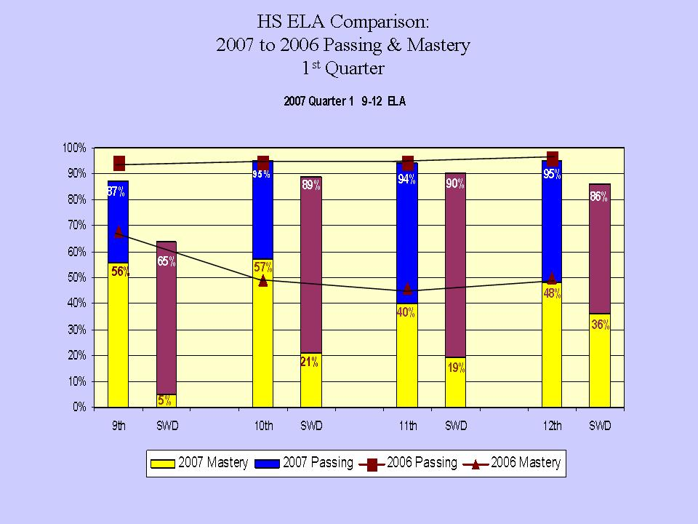

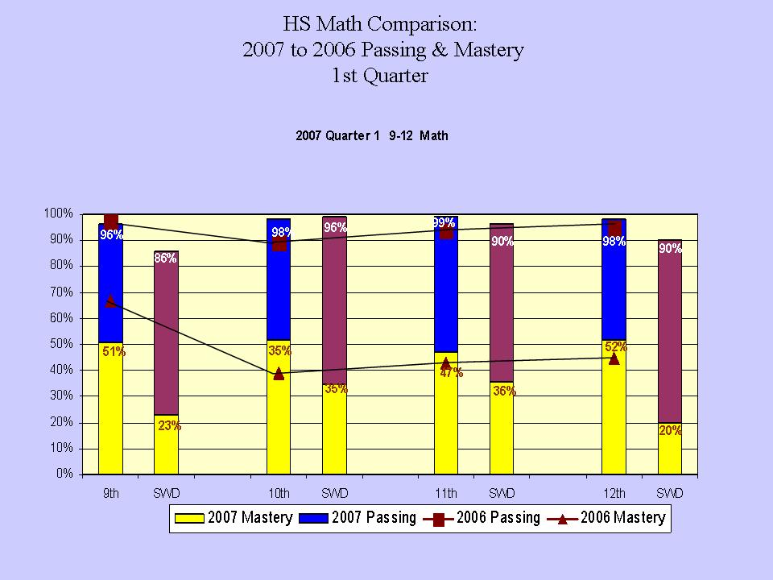

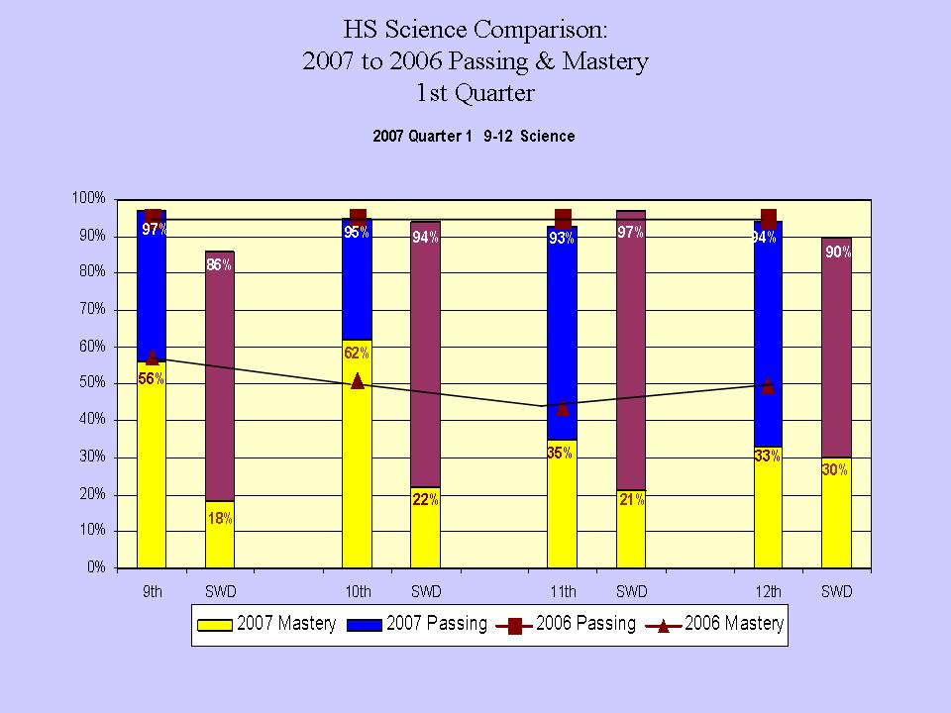

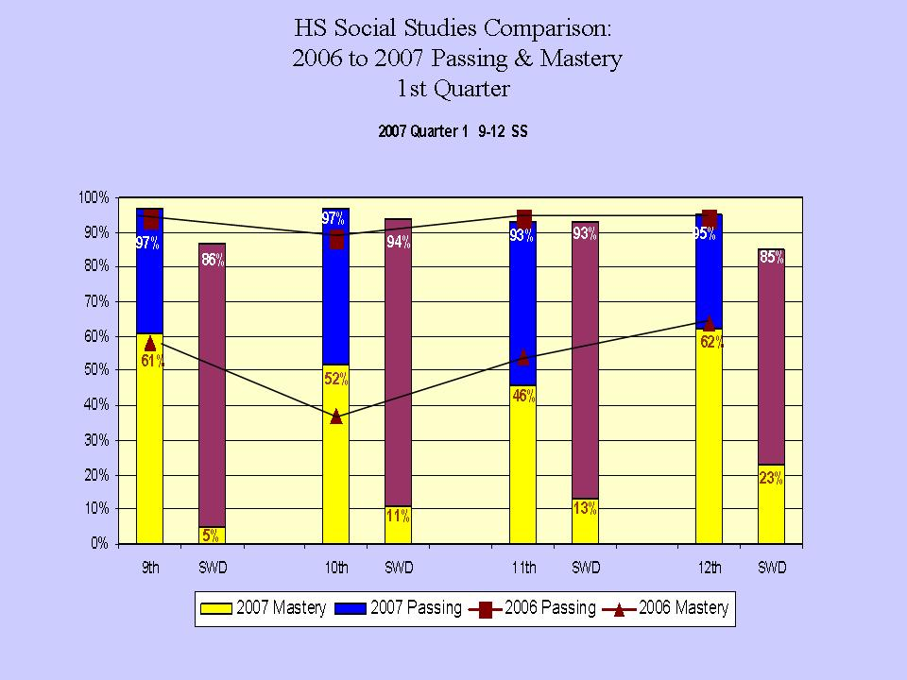

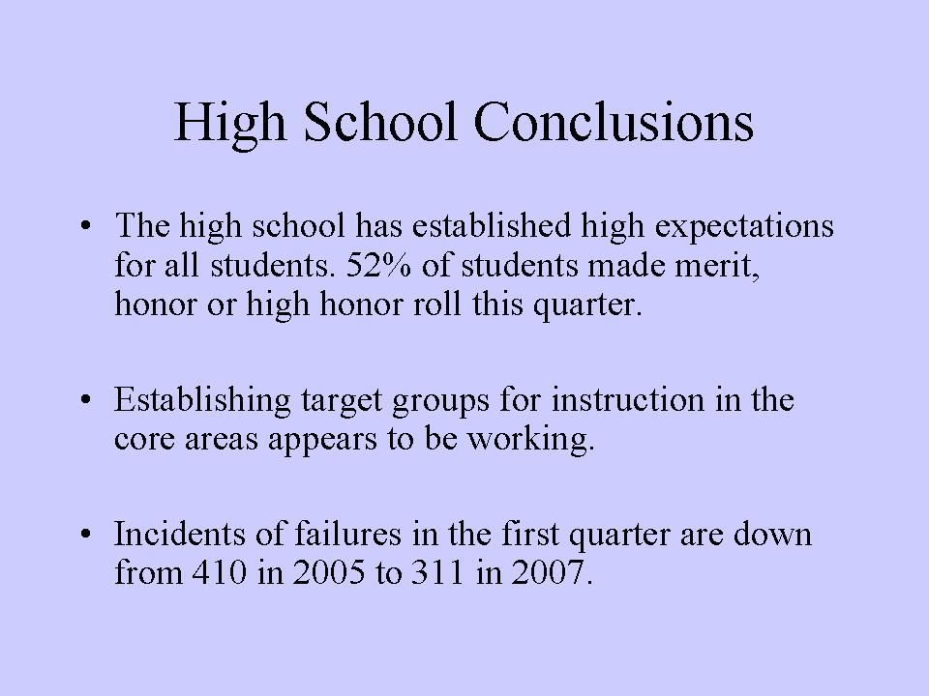

Att. 3
WAYNE CENTRAL SCHOOL DISTRICT
ONTARIO CENTER, NEW YORK
2008-2009 BUDGET PREPARATION CALENDAR

NOVEMBER
November 27, 2007, Tuesday Administrative Meeting:
Budget development calendar reviewed.
Budget development process reviewed.
Budget guidelines, instructions, and decision package forms distributed to building principals, central office administrators, and support staff supervisors.
Student enrollment projections for 2008-2009 reviewed.
Set Instructional Priorities.

DECEMBER
December 6, 2007, Thursday Board Meeting:
…………..Budget development calendar presented to Board of Education.
……………..2008-2009 enrollment projections to Board of Education.

JANUARY
January 3, 2008, Thursday Administrative Meeting:
…….. Staffing recommendations presented to Ass't Superintendents
by administrators.

January 10, 2008, Thursday Board Meeting
Discussion of Instructional priorities based on School Improvement Plan.
Board of Education Budget Discussion.
January 15, 2008, Tuesday Administrative Meeting:
Budget requests to be submitted by building principals, central office administrators, and support staff supervisors to Assistant Superintendent for Business.
Review first draft of 2008-2009 Capital portion of budget.
January 24, 2008, Thursday. .…………Board Meeting:
…………..Administrative presentation to Board of Education of the first draft of Capital portion of 2008-2009 budget
January 29, 2008, Tuesday Administrative Meeting:
Review first draft of 2008-2009 Program Budget.
FEBRUARY
February 7, 2008, Thursday Board Meeting:
Administrative presentation to Board of Education of the first draft of Program portion of 2008-2009 budget.
February 26. 2008, Tuesday Administrative Meeting:
Review first draft of 2008-2009 Administrative Budget.
MARCH
March 6, 2008, Thursday Board Meeting:
Administrative presentation to Board of Education of the first draft of Administrative portion of 2008-2009 budget.
Board of Education to identify propositions for May 13 Budget Vote and adopt Legal Notice of School Election and Budget Vote.
Board of Education review of first draft of complete 2008-2009 budget.
Administrative presentation of projected 2008-2009 revenues.
March 20, 2008, Thursday Board Meeting:
Board of Education discussion of draft of 2008-2009 Proposed Budget.
APRIL
April 3, 2008, Thursday Board Meeting:
…………..Adopt proposed 2008-2009 Wayne Central Budget.
April 14, 2008, Monday Petitions for School Trustee candidates to be filed with District Clerk on or before 5:00 p.m. at the District Office.
April 23, 2008, Wednesday Board Meeting:
…………..Vote on BOCES Administrative Budget.
April 29, 2008, Tuesday 2008-2009 proposed budget must be available for public inspection in each school building.
Last date for newsletter to be printed.
…………..Election of BOCES Board Members.
MAY
May 6, 2008, Tuesday Distribution of special edition of District newsletter with proposed 2008-2009 budget information.
May 8, 2008, Thursday Board Meeting:
Budget Hearing.
Board meeting to follow hearing.
…………..Appoint election officials for May 15 budget vote.
May 13, 2008, Tuesday Budget Vote at Wayne Central High School Gymnasium lobby from 9: 00 a. m. to 9: 00 p. m.

NOTICES PUBLISHED:
Must publish four (4) times within the seven (7) weeks preceding the Budget Vote.

The first notice must be 45 days prior to the Budget Vote week of (March 24, 2008)

 |  |  |  | Enrollment - October 1
 |  | 2007 (Actual) |  |  |  |  | 2008 (Projected)
OP | K | 124 | 7 | 17.7 |  | K | 110 | 6 | 18.3
 | 1 | 104 | 6 | 17.3 |  | 1 | 126 | 7 | 18.0
 | 2 | 117 | 7 | 16.7 |  | 2 | 106 | 6 | 17.7
 | Consortium | 7 |  |  |  | Consortium | 7
 |  | 352 |  |  |  |  | 349
OE | 3 | 120 | 6 | 20.0 |  | 3 | 118 | 6 | 19.7
 | 4 | 116 | 6 | 19.3 |  | 4 | 120 | 6 | 20.0
 | 5 | 130 | 6 | 21.7 |  | 5 | 119 | 6 | 19.8
 | Consortium | 8 |  |  |  | Consortium | 8
 |  | 374 |  |  |  |  | 365
FE | K | 48 | 3 | 16.0 |  | K | 70 | 4 | 17.5
 | 1 | 58 | 4 | 14.5 |  | 1 | 47 | 3 | 15.7
 | 2 | 58 | 3 | 19.3 |  | 2 | 58 | 3 | 19.3
 | 3 | 54 | 3 | 18.0 |  | 3 | 58 | 3 | 19.3
 | 4 | 66 | 3 | 22.0 |  | 4 | 56 | 3 | 18.7
 | 5 | 61 | 3 | 20.3 |  | 5 | 66 | 3 | 22.0
 | Consortium | 5 |  |  |  | Consortium | 5
 |  | 350 |  |  |  |  | 360
MS | 6 | 203 |  |  |  | 6 | 192
 | 7 | 201 |  |  |  | 7 | 202
 | 8 | 194 |  |  |  | 8 | 201
 | Consortium | 25 |  |  |  | Consortium | 25
 |  | 623 |  |  |  |  | 620
HS | 9 | 217 |  |  |  | 9 | 200
 | 10 | 216 |  |  |  | 10 | 198
 | 11 | 232 |  |  |  | 11 | 215
 | 12 | 227 |  |  |  | 12 | 230
 | Consortium | 31 |  |  |  | Consortium | 31
 |  | 923 |  |  |  |  | 874
K-12 Total |  | 2622 |  |  |  |  | 2568
Att. 4
WAYNE CENTRAL SCHOOL DISTRICT

To: Board of Education

From: Michael Havens, Superintendent of Schools
(Prepared by Mark D. Callahan, Director of Human Resources)

Re: Personnel Action

Date: December 6, 2007

The following is submitted for your review and approval.

INSTRUCTIONAL STAFF

TENURE APPOINTMENT RECOMMENDATION:

John Cotsonas, Physical Education Teacher, assigned to the James A. Beneway High School, a tenure appointment effective January 3, 2008.

LEAVE OF ABSENCE:

Megan Mahaney, Reading Teacher (LTS), assigned to the Freewill Elementary School, a paid FMLA leave of absence to commence on or about April 21, 2008 and expire on or about
May 30, 2008. For the purpose of child rearing.

APPOINTMENT:

Angela Wasserman, Art Education Teacher, NYS Control No. 81395071 (Initial valid through 9/1/2012) assigned to the Ontario Primary School, a three year probationary appointment effective December 10, 2007 through December 9, 2010 at $36,600 (base) credited with no service. Replacement for Patrice Ott (resignation).

SUPPORT STAFF

RESIGNATIONS:

Heidi Ward, Teacher Aide (1:1), assigned to the Freewill Elementary School, effective November 16, 2007. For personal reasons.

LEAVE OF ABSENCE: None

APPOINTMENTS:

Frank Carlesimo, Bus Driver, assigned to the Transportation Department, a 6 month probationary Civil Service appointment effective October 24, 2007 through April 23, 2008 at $13.14 per hour. To replace Delbert Rohring (resigned).

Dawn Brogan, Cleaner, assigned to the Thomas C. Armstrong Middle School, having successfully completed a six month probationary review, a permanent Civil Service appointment effective November 15, 2007 at her current rate of pay.

Megan Enright, Teaching Assistant (1:1), assigned to the Ontario Elementary School, a seven month temporary appointment effective November 26, 2007 through June 30, 2008 at $12.02 per hour. New position.

James Long, Maintenance Worker, assigned to the Facilities and Maintenance Department, having successfully completed a six month probationary review, a permanent Civil Service appointment effective November 3, 2007 at his current rate of pay.

2007-08 ANNUAL STIPEND APPOINTMENTS (AMENDED):
❖ Club Advisors -
 | Name |  | Activity | Bldg. |  | Rate
 | Julie Schwartz |  | Peer Mediation | HS |  | $626.00

❖ Advisors: rate – varies per activity
Name |  | Activity | Bldg. | Rate | Amount
James Herendeen |  | Musical Accompanist | HS | $626 | $626

❖ Team Leaders: rate - $1,959 plus $100 per supervised teacher (amended)
Name |  | Grade Level | Bldg. | #Tchr | Amount
Deb Bussard |  | Grade 6 Pluto | MS | 4.32 | $2,391
Gale McAndrew |  | Grade 6 Venus | MS | 4.32 | $2,391

Winter 2007-08 Season Length (11-5-07 to 3-7-08)
Name | Team | Step | WCS Years | Level | Incentive | Salary | Total
Christina Grey | JV Cheerleading | 1 | 1 | E |  | 2711 | 2711
Jeff Ugine | Boys JV Basketball | 5 | 1 | B |  | 4377 | 4377
- replaces Rich Miles (resigned 10/20/07)
Ron Gross | Asst. Varsity Wrestling | 17 | 3 | F |  | 3385 | 3385
Russ Watson | G & B Asst. Indoor Track | 14 | 2 | E |  | 3462 | 3462

Athletic Event Staff:
Tiffany Cotsonas
Dave Leone
Tom Gentile

Post-Season play -Sectionals:
Craig Wert – Boys Varsity Volleyball

The following Varsity Coaches should receive $388.00 for Post-Season play -Sectionals:
Carl Johnston –Girls & Boys Varsity X-C
David Marean – Varsity Football
Tim Mattle – Boys Varsity Soccer
Bill Jordan – Girls Varsity Soccer
David Hosenfeld – Girls Varsity Volleyball
Dolores Fox – Girls Varsity Tennis

The following JV/Assistant Coaches should receive $155.00 for Post-Season play -Sectionals:
Alan Balcaen - Asst. Varsity Football
Mike Grasta – Asst. Varsity Football
Gissela Bueso – JV Girls Volleyball
Riley Wheaton- JV Boys Soccer
Bob Taylor – JV Girls Soccer
Betsy Cavallaro- Varsity Cheerleading
Sandy Bueso – JV Boys Volleyball

Att. 5

Meeting | Alt. ID# | Age | Committee | Grade | Reason | Decision | Disability | Rec.  School
11/13/2007 | 8342 | 12:8 | Section 504 | 07 | Initial Eligibility Determination Mtg. | Section 504 | Limited Major Life Activity | Wayne Central Middle School
11/13/2007 | 98241 | 8:4 | Section 504 | 03 | Initial Eligibility Determination Mtg. | Section 504 | Limited Major Life Activity | Ontario Elementary
11/13/2007 | 98974 | 9:11 | Section 504 | 04 | Initial Eligibility Determination Mtg. | Section 504 | Limited Major Life Activity | Ontario Elementary
11/13/2007 | 98868 | 8:0 | Section 504 | 03 | Initial Eligibility Determination Mtg. | Section 504 | Limited Major Life Activity | Ontario Elementary
Committee Recommendations for Board of Education Review (December 6, 2007)

Meeting | Alt. ID# | Age | Committee | Grade | Reason | Decision | Disability | Rec.  School | Rec.  Program
8/23/07 | 97506 | 10:11 | Sub CSE | 06 | Initial  Eligibility  Determination  Mtg. | Classified | Other Health Impairment | Wayne Central Middle School | Consultant Teacher
9/20/07 | 99116 | 7:3 | CSE | 02 | Initial Eligibility Determination Mtg. | Classified | Learning Disability | Ontario Primary | Consultant Teacher  Speech/Language Consultation  Speech/Language Therapy
11/1/07 | 97595 | 10:7 | CSE | 05 | Initial Eligibility Determination Mtg. | Classified | Speech or Language Impairment | Ontario Elementary | Consultant Teacher  Consultant Teacher  Speech/Language Therapy  Speech/Language Therapy
11/15/07 | 9300 | 12:10 | CSE | 07 | Initial Eligibility Determination Mtg. | Classified | Learning Disability | Wayne Central Middle School | Consultant Teacher
11/15/07 | 96224 | 13:3 | CSE | 08 | Initial Eligibility Determination Mtg. | Classified | Other Health Impairment | Wayne Central Middle School | Consultant Teacher  Consultant Teacher
Committee Recommendations for Board of Education Review (December 6, 2007)

Att. 6

WAYNE CENTRAL SCHOOL DISTRICT
Consensus Agenda

TO: Board of Education

FROM: Michael Havens

RE: Consensus Agenda

DATE: December 6, 2007

The following items are being recommended for approval in a consensus agenda:

Item #1 Approve October Treasurer’s Report

Item #2 Approve Surplus Property Designation

Item #3 Accept Gift to the District

Item #4 Award Boces Co-Op Bid for Computers, Software, Technology Engineering and
Supplies for Project Lead the Way

Item #5 Accept Audit Report

Consensus Agenda Item #1

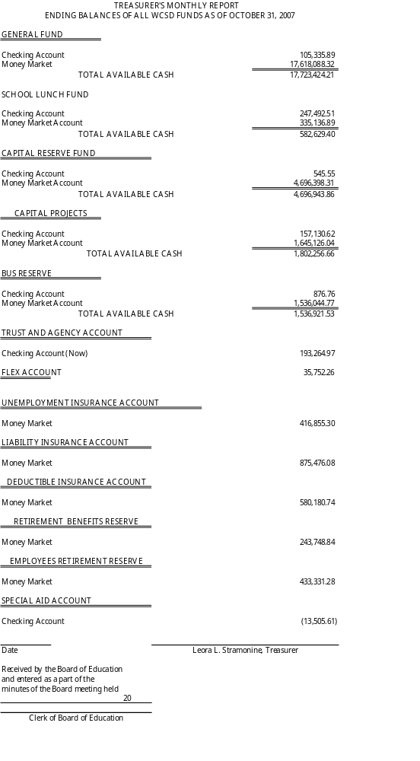
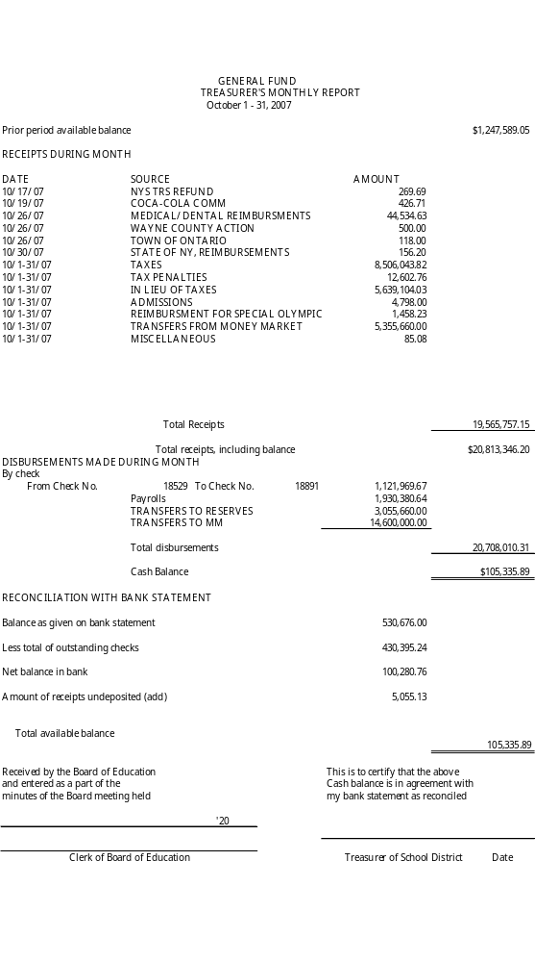
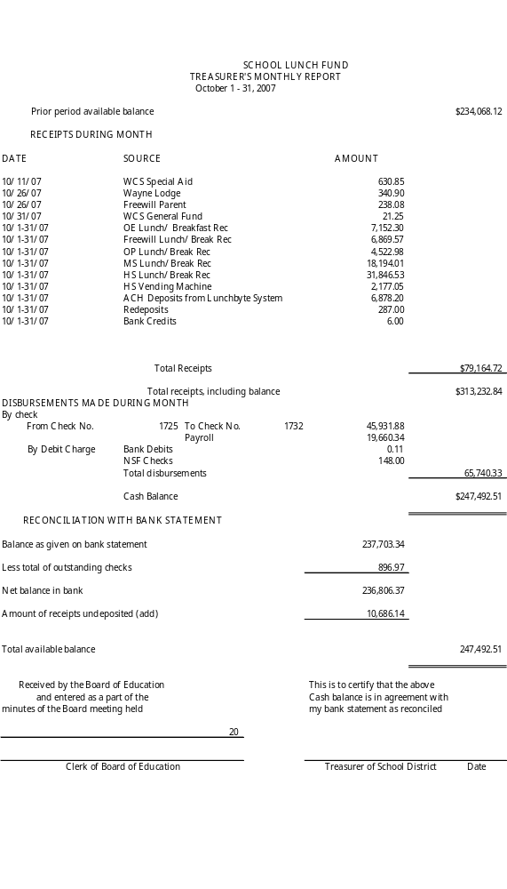
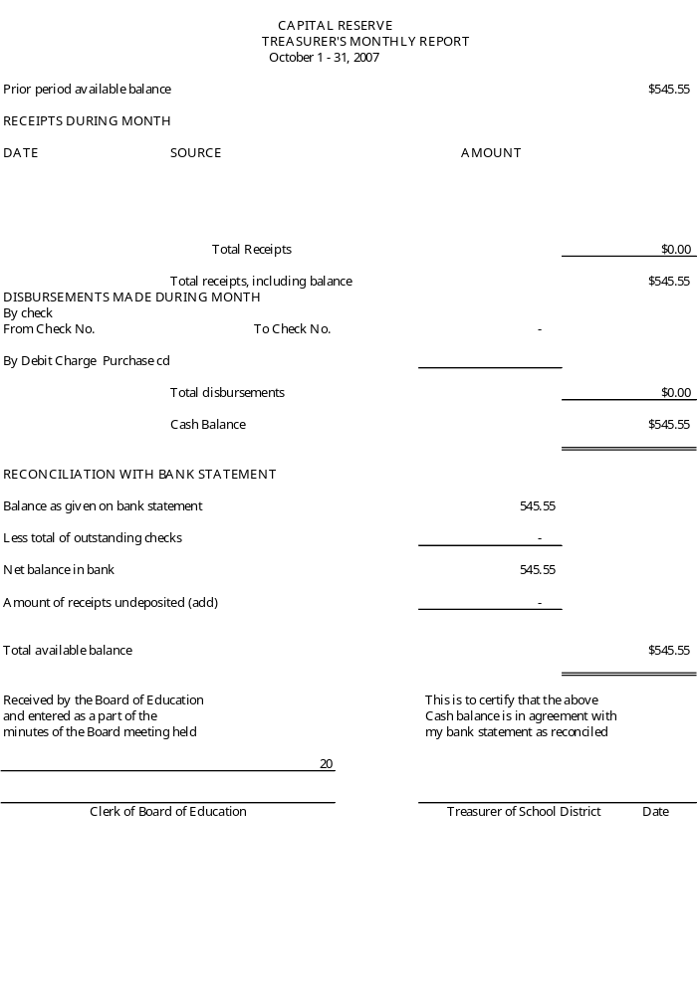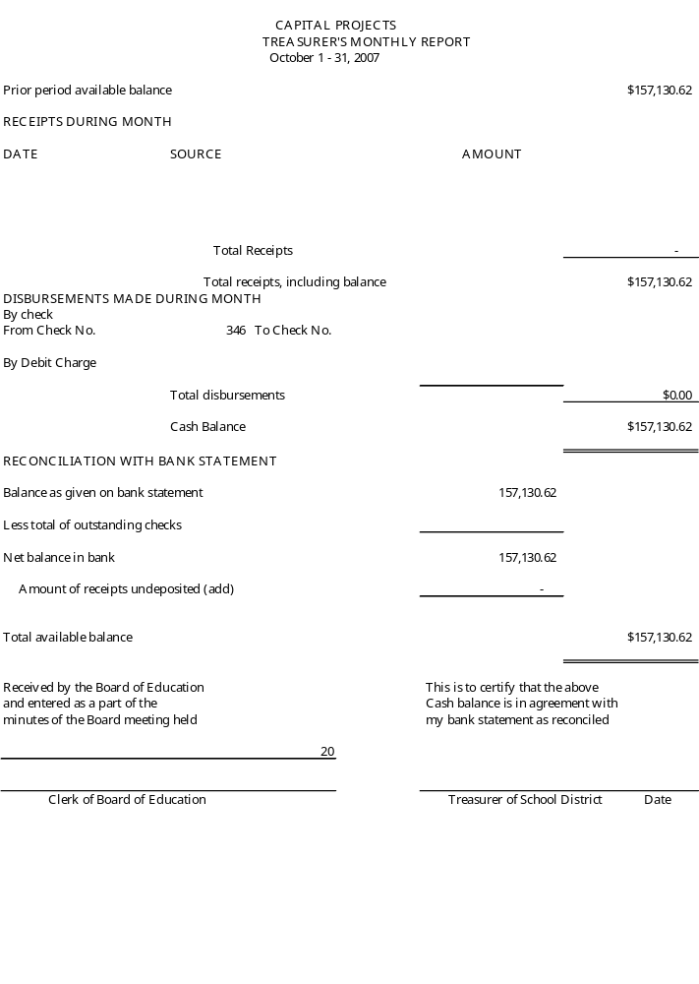
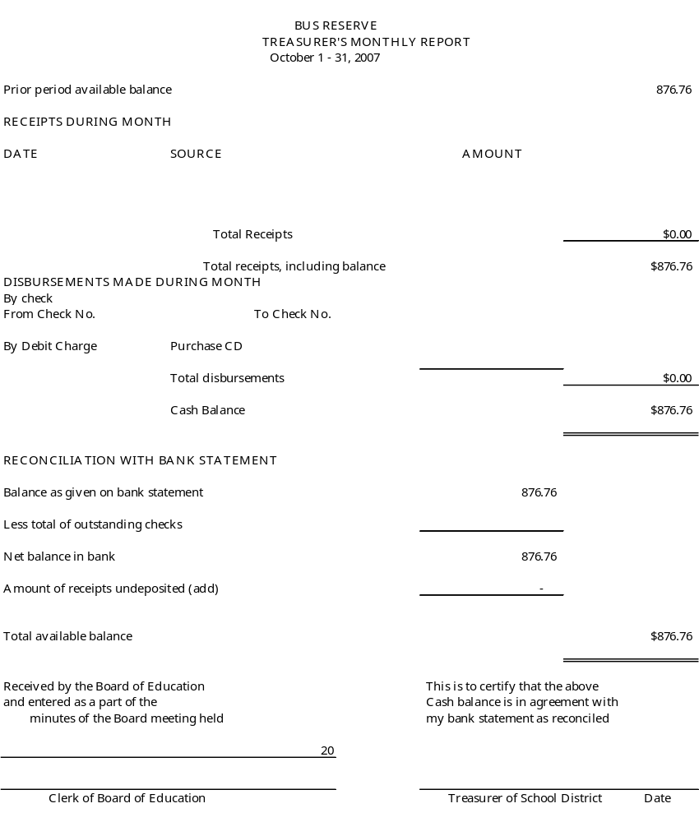
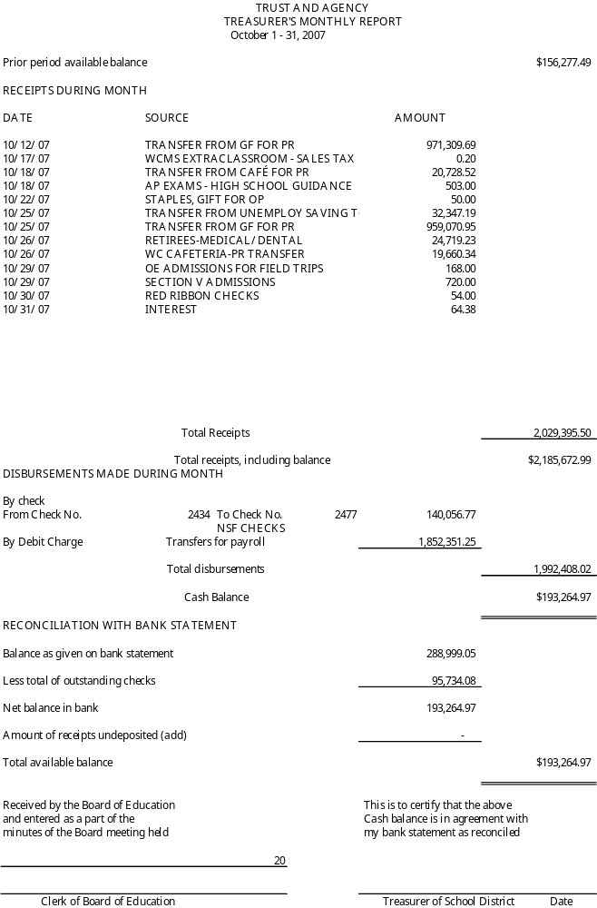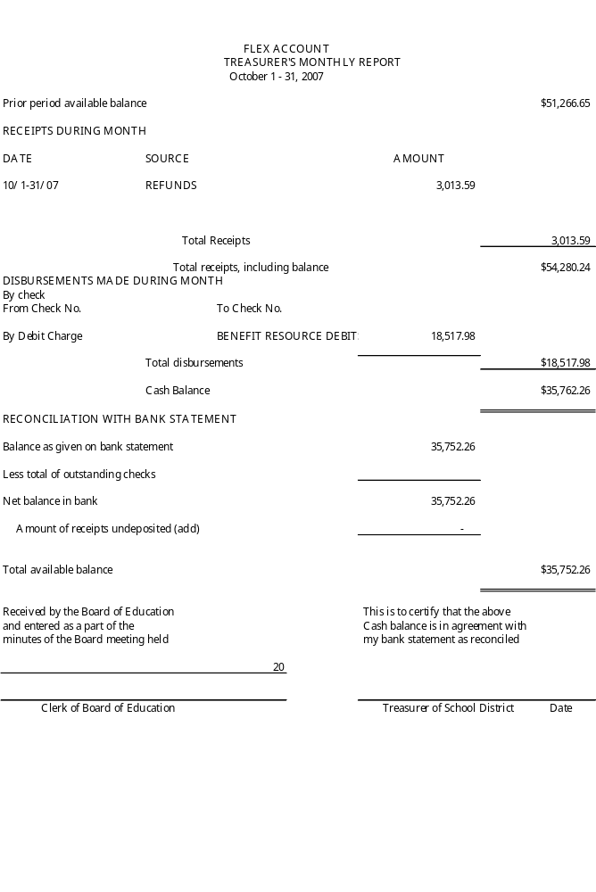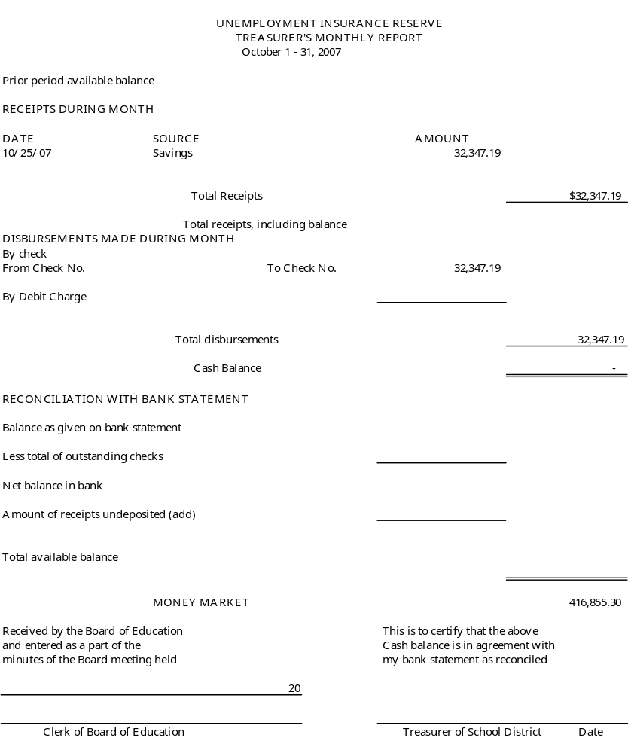
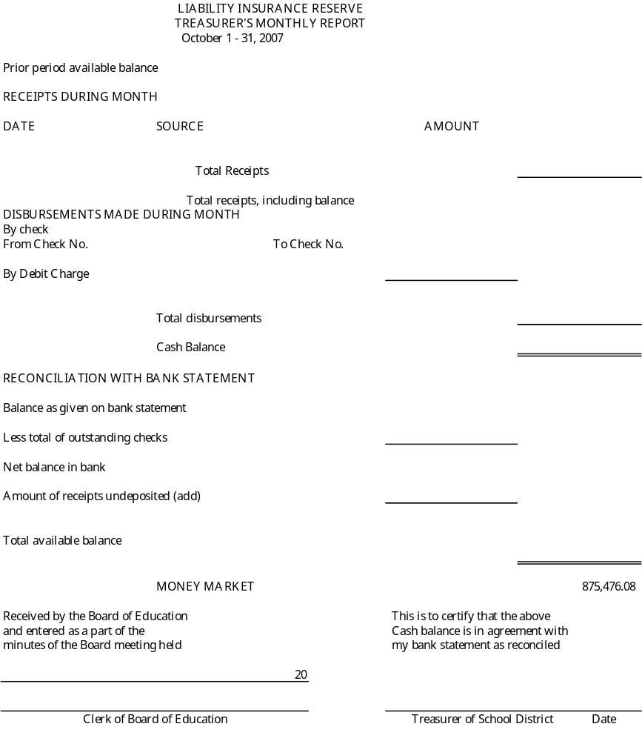
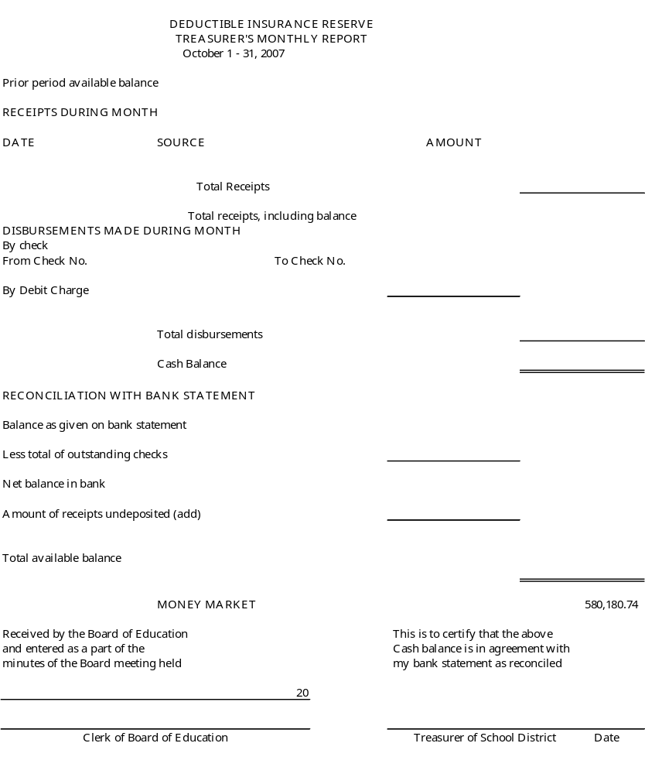
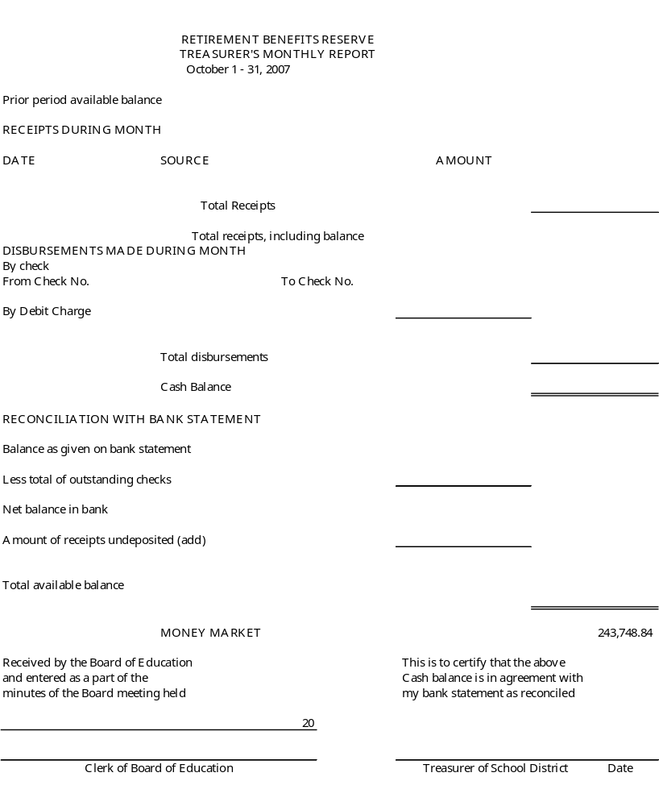
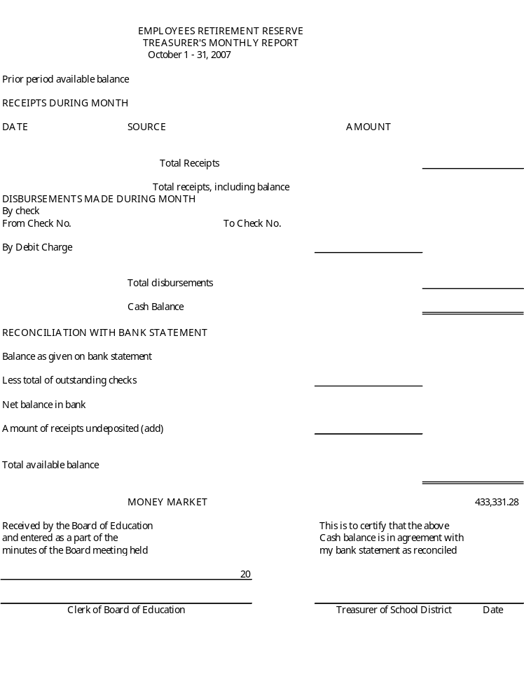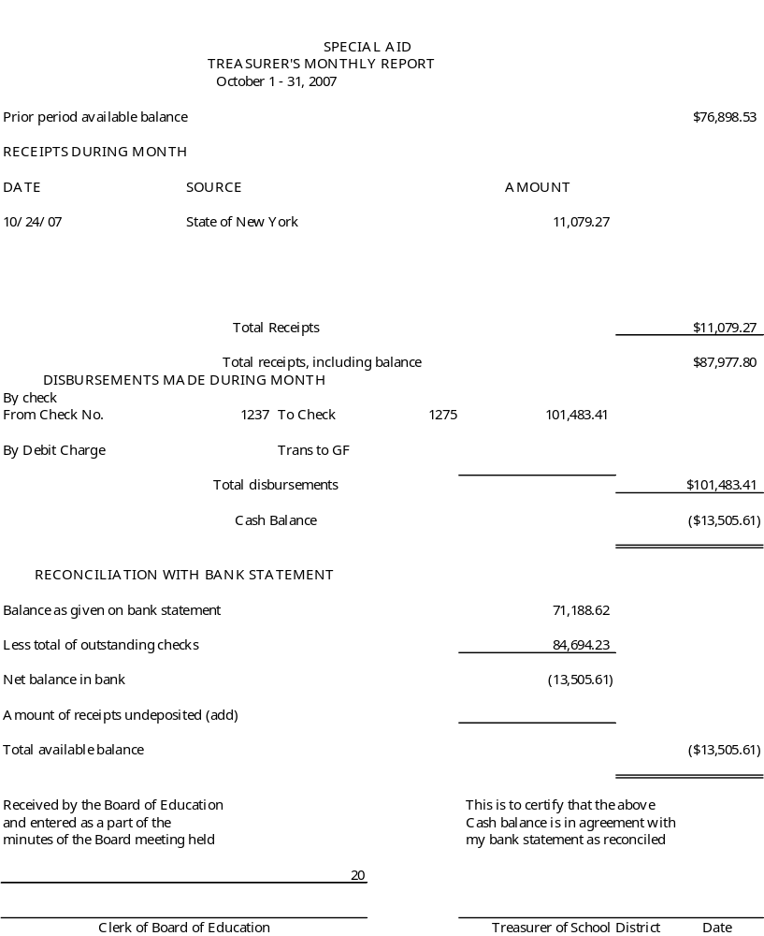

Consensus Agenda Item #2

TO: Michael Havens
Superintendent of Schools

FROM: Gregory J. Atseff
Assistant Superintendent for Business
DATE: December 6, 2007
RE: Declare School Vehicles as Surplus Property

Recommend that the Board of Education at their regular meeting scheduled for Thursday, December 6, 2007, declare school buses #205, #209, #210, #211, #227, and #229 as surplus property. This procedure is in accordance with Policy #5250.

Bus # 205 – 1997 International, 66-passenger bus

Bus # 209 – 1997 International, 66-passenger bus
Bus # 210 – 1997 International, 66-passenger bus

Bus # 211 – 1997 International, 66-passenger bus
Bus # 227 – 2000 Chevy, 20-passenger bus
Bus # 229 – 2000 Chevy, 20-passenger bus

Once the vehicles have become surplus property, they will be traded, sold through the bid process, or sold at public auction. Proceeds from the sale will be deposited in the Bus Purchase Reserve Fund.

GJA/db

c: Fred Prince, Transportation Manager
Lee Stramonine, Treasurer
Helen Jensen, Business Office
m

Consensus Agenda Item #3

TO: Michael Havens
Superintendent of Schools

FROM: Gregory J. Atseff
Assistant Superintendent for Business
DATE: December 6, 2007
RE: Gifts to the District

Recommend that the Board of Education, at their meeting to be held on December 6, 2007, accept the following gifts:
- a gift of $4,000 from the Freewill Parent Group to be used toward the purchase of SMART board systems
- a gift of $3,500 from the Wayne High School Music Boosters to be used towards the funding of the April band trip

/db

c: Lee Stramonine
Jona Wright
Joe Siracuse
Helen Jensen

Consensus Agenda Item #4

TO: Michael Havens
Superintendent of Schools

FROM: Gregory J. Atseff
Assistant Superintendent for Business

DATE: December 6, 2007

RE: BOCES Cooperative Bid for Computers, software, technology engineering and supplies (Project Lead the Way)

At the August 16, 2007, regular board meeting, the Board of Education approved a resolution for participation in Monroe 2-Orleans BOCES cooperative bid for purchases of Computers, Software, and Technology Engineering Equipment and Supplies. Monroe BOCES 2 Bid RFB-1308-07 was opened on September 6, 2007 at 2:00 p.m. and Bid RFB-1347-07 was opened on October 31, 2007 at 2:00 p.m. Monroe 2-Orleans BOCES recommends each district approve awards to the following organizations. The amount of the award is based on cost per unit, not total pricing. Detailed prices for each item will be found on the Project Lead the Way web site at time of purchase.

I recommend that we accept the recommendation of Monroe 2 Orleans BOCES to award the bids to the lowest responsible bidders as stated below.

Vendor Estimated Award
AC Supply  1746 Winding Glen Dr., PO Box 1523  St. Charles, MO 63302 | $ | 725.68
B&H Photo Video pro-Audio  420 Ninth Ave.  New York, NY 10001 |  | 1,291.80
Breadboard Companion  9078 Dover St.  Westminster, CO 70021 |  | 227.76
Brite Computers, Inc.  7647 Main St. Fishers  Victor, NY 14564 |  | 1,553.08
Dimension 3D Printing  7665 Commerce Way  Eden Prairie, MN 55344 |  | 14,999.00
Electronix Express RSR Electronics, Inc.  365 Blair Rd.  Avenel, NJ 07001 |  | 59,152.45
Elenco Electronics  150 W. Carpenter Ave.  Wheeling, IL 60090 |  | 1,463.28
Global Gov’t/Education Solutions Inc.  6990 US Route 36 East  Fletcher, OH 45326 |  | 678.65
Govconnection, Inc.  706 Milford Rd.  Merrimack, NH 03054-4633 |  | 688.75
Great Lakes Electronic Distributing  22 James E. Casey Dr.  Buffalo, NY 14206 |  | 23,106.00
Kelvin LP  280 Adams Blvd.  Farmingdale, NY 11735 |  | 95.50
Metco Supply  81 Kiski Ave.  Leechburg, PA 15656 |  | 522.48
Mouser Electronic  1000 N. Main St.  Mansfield, TX 76063 |  | 119.415
Multiwave  20153 Paseo Del Prado  Walnut, CA 91789 |  | 9.00
Pasco  10101 Foothills Blvd.  Roseville, CA 95747-7100 |  | 151.05
Paxton/Patterson  7523 S. Sayre Ave.  Chicago, IL 60638 |  | 3,220.37
Pitsco  PO Box 1708  Pittsburg, KS 66762 |  | 34.57
School World  375 Woodcliff Dr.  Fairport, NY 14450 |  | 11.970
Shortess-Rawson & Associates  PO Box 5  Green village, NJ 07935-005 |  | 12,817.00
Synergy Global Solutions  1100 Pittsford-Victor Rd.  Pittsford, NY 14534 |  | 10,493.85
Teacher Geek  68 Lacy Lane  Brockport, NY 14420 |  | 1,575.36
Tech Depot  6 Cambridge Dr.  Trumbull CT 06611 |  | 246.61
Virco  PO Box 5000  Highway 65 South  Conway, AR 72032 |  | 12,469.08
 | $ | 145,652.705

Consensus Agenda Item #5

To: Michael Havens, Superintendent of Schools

From: Gregory Atseff, Assistant Superintendent for Business

Date: November 30, 2007

Re: Independent Auditor’s Report and Management Letter

At the November 1, 2007 board meeting, the Board of Education received a copy of the General Purpose Financial Statements and the Management Letter for the school fiscal year ended June 30, 2007. At that time, the audit committee recommended that the Board of Education adopt a resolution at the December 6, 2007 meeting accepting the audit report and management letter.

Please present the following resolution to the Board of Education at their meeting on December 6, 2007:

Resolution

Resolved; that upon the recommendation of the Superintendent of Schools, the Board of Education of the Wayne Central School District hereby accepts the Independent Auditor’s Report and the Management Letter for the fiscal year 2006-2007.

/db
.Att

Att. 7

Policy Submitted for First Reading

1230 Policy Reporting Campaign Expenses

1240 Policy Resignation, Dismissal & Vacancy – Board of Education

1300 Policy Powers & Duties – Board of Education

1310 Policy Appointment & Duties – School District Clerk

1313 Policy Re-Organizational Meeting of the Board of Education

1320 Policy Appointment & Duties - School District Treasurer

1340 Policy Appointment & Duties - External Auditor

1350 Policy Appointment & Duties - Internal Claims Auditor

1360 Policy Appointment & Duties - Extra-Classroom Activities Fund – Treasurer

1370 Policy Appointment & Duties - School Attorney

1380 Policy Appointment & Duties - School Physician

1410 Policy Formulation & Adoption of Board of Education Policy

1520 Policy Special Emergency Meetings

5321 Policy Reimbursement for Travel & Conference Expenses

Policy Submitted for Single Reading

5321 Regulation Reimbursement for Travel & /Conference Expenses

12/6/07 Board Meeting
Presented for First Reading on December 6, 2007
New Text in Blue Type, Underlined Text Is Deleted 1230

By-Laws

REPORTING OF CAMPAIGN EXPENDITURES

Each candidate for the position of member of the Board of Education whose expenses, or contributions received by him or her, exceed $500.00 must file a sworn, itemized statement accounting for his or her their campaign expenditures and contributions. These statements are filed with both the school district clerk and the Commissioner of Education, itemizing such expenditures and/or contributions.

In the event the expenses, or contributions received by him or her, do not exceed $500.00, in the aggregate, then a sworn statement to that effect must only be filed only with the school district clerk.

A preliminary statement must be filed no later than thirty (30) days before the election.

The second statement shall be filed no later than five (5) days before the election.

The third and final statement shall be filed within twenty (20) days after the election. Each statement must cover the period up to an and including the day before the day specified for the filing of the statement.

Any contribution or expense, however, in excess of $1,000 that is received after the closing date for the most recent required statement, but before the election, must be reported, in the same manner as other contributions, within twenty-four (24) hours after its receipt.

Persons who make expenditures of $25.00 or more on the candidate’s behalf, without the candidate’s approval, must also file a sworn statement with the school district clerk that such expenses were not approved by the candidate.

All statements must be sworn before a notary public, a commissioner of deeds, a lawyer or a public official authorized by New York State law to administer oaths.

Each statement is deemed filed when it is deposited in an established post office within the prescribed time, duly stamped, registered and directed to the school district clerk and, if necessary, the Commissioner of Education. Each statement shall be preserved for a period of three (3) years from the date of filing thereof and is considered a public record open to public inspection.

Education Law § 1528 and 1529, As Amended

ADOPTED: September 10, 2003 REVISED : January 26, 2006 REVISED : January .., 2008

Policy Handbook • Wayne Central School District • Ontario Center, New York 14520

Presented for First Reading on December 6, 2007
New Text in Blue Type, Underlined Text is Deleted 1240

By-Laws

RESIGNATION, DISMISSAL AND VACANCY

Board of Education members may resign at the annual district meeting, by filing a written resignation with the district (B.O.C.E.S.) superintendent of schools or by delivering or filing said written resignation with the school district clerk, who must then notify the Board of Education. at any Board of Education meeting, at which time The resignation shall be automatically accepted and reflected in the minutes of said the meeting when presented to the Board of Education.

The resignation shall take effect upon the date specified in the letter of resignation; however, if no effective date is specified, it shall take effect on the date of delivery to or filing with the school district clerk. If an effective date is specified in the letter of resignation, such date shall not be more than thirty-(30) days subsequent to the date of its delivery or filing.

It shall be the duty of each member of the Board of Education to attend all meetings of the Board of Education and. If if any member shall fail to attend three (3) consecutive meetings of the Board of Education after having been regularly notified and not having shown a satisfactory cause for each non-attendance, the Board of Education will proceed to declare that office vacant.

A board member may be removed from office by the Commissioner of Education for willful violation of any provision of law, neglect of duty, or willfully disobeying any decision, order or regulation of the Commissioner of Education.

In the event of death, resignation, refusal to serve, or any disqualification of a board member, the Board of Education may appoint a new member to fill such a vacancy. If the Board of Education chooses to fill the vacancy, it shall be only for a term ending with the next annual election of the school district at which time such vacancy shall be filled in a regular manner for the balance of the unexpired term. The Board of Education, at its own option, may also elect to call a special election, within ninety-(90) days, to fill the unexpired term.

The Commissioner of Education may order a special election for filling a vacancy. When such special election is ordered, the vacancy shall not be filled otherwise.

A board member who has been removed from office shall be ineligible to for appointment or election to any office in the district for a period of one (1) year from the date of such removal.

Education Law §§ 306, 1706, 1709(17)(18),2103(2), 2109, 2111, 2112, and 2113
Public Officers Law §§30, 31 and 35

ADOPTED: September 10, 2003 REVISED: January ..,. 2008

Policy Handbook • Wayne Central School District • Ontario Center, New York 14520

Presented for First Reading on December 6, 2007
New Text in Blue Type, Underlined Text Is Deleted 1300

By-Laws

POWERS AND DUTIES OF THE BOARD OF EDUCATION

The Board of Education shall have powers and duties as set forth in New York State Education Law, principally Articles 35 and 37, and other applicable federal and state laws and regulations.

In general, the Board of Education shall have, in all respects, the superintendence, management and control of the educational affairs of the district and shall have all the power and authority as necessary to exercise these those powers expressly granted to it by the laws of New York State and the Regulations of the Commissioner of Education.

Reference:

Education Law §1604, 1709 and 1804
Policy #6540 – Defense and Indemnification of Board Members and Employees

ADOPTED: September 10, 2003 REVISED: January…, 2008

Policy Handbook • Wayne Central School District • Ontario Center, New York 14520
Presented for First Reading on November 15, 2007
New Text in Blue Type, Underlined Text Is Deleted 1310

By-Laws

APPOINTMENT & DUTIES OF THE SCHOOL DISTRICT CLERK

Job Description

The Board of Education shall annually appoint the school district clerk. The school district clerk is appointed each year by the Board of Education at the re-organizational meeting. This Such appointment shall continue until the next re-organizational meeting. The salary of the school district clerk shall also be fixed annually at the re-organizational meeting.

The school district clerk shall:

- Have working knowledge of State Education Law concerning the office of school district clerk such as procedures for annual and special school elections, candidate petitions and qualifications, & tenured teacher tenure disciplinary hearings;
- Hold commission as a notary public;
- Verify and sign official documents;
- Conduct annual and special elections and special district referenda & oversee coordinate absentee balloting;
- Notify the town clerk in each component town of the results of all elections and school district votes;
- Officially notify persons duly elected or appointed to office within twenty-four (24) hours;
- Notify the county treasurer of persons appointed as district treasurer and school tax collector;
- Administer the oath of office to new trustees members of the Board of Education;
- Maintain all official records of the school district;
- Call all meetings to order in the absence of the President and Vice President;
- Keep the policy manual of the Board of Education and add and distribute material to the Board of Education and administrators after school board action;
- File all correspondence and records relating to matters of the school district involving the Board of Education;
- Keep and file all information regarding special committees of the Board of Education;
- Prepare and arrange for publication of legal notices;
- Attend and prepare minutes of all public meetings of the Board of Education, both regular and special, as well as public hearings of the Board of Education, and, when requested, handle follow-up correspondence
- Prepare minutes of executive sessions as established by law
- Prepare the expenses of school elections, the district clerk and records management for the annual budget;
- Participate in logistics of bond sales to ensure successful completion;
- Receive subpoenas and claims against the school district as well as process appeals to the Commissioner of Education;
- Perform any other duties requested by the Board of Education or superintendent of schools or required by law

If a vacancy occurs, the Board of Education may appoint a successor. Only the Commissioner of Education, in accordance with State Education Law, may remove the school district clerk.

Education Law, §306, 902, 2121, 2122, 2130

ADOPTED: September 10, 2003 REVISED: December .., 2007

Policy Handbook • Wayne Central School District • Ontario Center, New York 14520

Presented for First Reading on December 6, 2007
New Text in Blue Type, Underlined Text Is Deleted 1350

By-Laws

APPOINTMENT AND DUTIES OF THE INTERNAL CLAIMS AUDITOR

Job Description

The Board of Education will designate and appoint a/an internal claims auditor(s) for the school district at the re-organizational meeting. The internal claims auditor(s) shall serve at the pleasure of the Board of Education. The internal claims auditor (s) is/are responsible for formally examining allowing or rejecting all accounts, charges, claims or demands against the school district. The internal claims auditor will provide reports and recommendations to the audit committee as provided by law, regulation and policy of the Board of Education.

The internal auditing process should determine that the:

- proposed payment is for a valid and legal purpose.

- obligation was incurred by an authorized school district official,

- items for which payment is claimed were in fact received or, in the case of services, were actually rendered,

- submitted claim voucher is in the proper form, mathematically correct, does not include previously paid charges, and is in agreement with the purchase order or contract upon which it is based

- submitted claims voucher meets such other requirements as may be established by the Regulations of the Commissioner of Education and/or the Comptroller of the State of New York.

The internal claims auditor(s) shall have access to all documents regarding financial transactions to ensure that such documents are in compliance with the law, district policy and regulations. Questions or unresolved issues will be directed to the President of the Board of Education.

The school district treasurer shall need the signature of approval of the internal claims auditor for payment of a warrant, invoice or payroll. It shall constitute the same authorization for payment as a resolution of the Board of Education.

No person shall be eligible for appointment to the office of internal claims auditor who shall be:

- A member of the Board of Education
- The district clerk or district treasurer of the Board of Education
- The school district official responsible for business management
- The purchasing agent
- Clerical personnel directly involved in accounting and purchasing functions

ADOPTED: September 10, 2003 REVISED: January …, 2008

Policy Handbook • Wayne Central School District • Ontario Center, New York 14520

Presented for First Reading on December 6, 2007
New Text in Blue Type, Underlined Text Is Deleted 1360

By-Laws

APPOINTMENT & DUTIES OF EXTRA-CLASSROOM ACTIVITY TREASURER (S)

The Board of Education has the responsibility for the protection and supervision of the financial affairs of student clubs and extracurricular activities. An extra-classroom activity is defined as an organization whose activities are conducted by students and whose financial support is generated other than by taxation or through charges of the Board of Education.

On an annual basis at the re-organizational meeting, the Board of Education shall approve the appointment of a competent and qualified person to serve as a faculty advisor for each club or organization.

Management of Student Activities Funds

The Board of Education directs that the monies received from the conduct, operation or maintenance of any extra-classroom activity are deposited with transmitted to the person(s) designated as the treasurer (s) of such extra-classroom activity fund who shall deposit them in one of the official depositories designated by the Board of Education.. The signatures of at least two (2) authorized individuals, including the student activity treasurer, are required for disbursement from an account.

The central treasurer(s) of extra-classroom activity funds will submit quarterly reports to the Board of Education. The school district’s independent external auditor shall make conduct an audit of all extra-classroom activity funds on an annual basis

Generally, all moneys collected in a school building, whether by personnel or by vending machines, are to be deposited in and processed through the extracurricular activity fund except where otherwise required designated or upon separate approval by the building principal or superintendent of schools, or designee.

Records of receipts and expenditures are to be maintained, including: This includes:

a) Monies collected by students and expended by them for extra-classroom activities;
b) Monies collected by school personnel for field trips or similar activities; and
c) Other non-property tax monies collected in a school building for school purposes.

Authority to expend moneys shall be distinct and separate from the custody of those monies. Funds of an inactive organization shall become part of the general fund of the school district.

Regulations for the establishment, conduct, operation and maintenance of extra-classroom activities and for the safeguarding, accounting and audit of all monies received will be developed by the superintendent of schools for review and approval by the Board of Education.
Education Law §207, 8 NYCRR Part 172

ADOPTED: September 10, 2003 REVISED: January …, 2008

Policy Handbook • Wayne Central School District • Ontario Center, New York 14520

Presented for First Reading on December 6, 2007
New Text in Blue Type, Underlined Text Is Deleted
1370

By-Laws

APPOINTMENT & DUTIES OF THE SCHOOL ATTORNEY

The Board of Education shall employ a school attorney who shall be responsible to the Board of Education for guidance on all affairs that are of a legal nature. including, but not limited to:

- Negotiation of all legal charges and processes for each bond issue and construction and/or reconstruction of new buildings;

- Legal counsel on matters referred to him or her to determine legality of procedure;

- Matters related to "due process" hearings or procedures.

Adopted: September 10, 2003 REVISED: January …, 2008

Policy Handbook • Wayne Central School District • Ontario Center, New York 14520

Presented for First Reading on December 6, 2007
New Text in Blue Type, Underlined Text Is Deleted
1380

BY-LAWS

APPOINTMENT & DUTIES OF THE SCHOOL PHYSICIAN

The school physician(s) shall be appointed by the Board of Education. The duties of the school physician(s) shall include, but are not limited to, the following:

- Performs professional medical services in the examination and care of school children;

- Supervises routine examinations of school children by the school nurse practitioner to detect the presence of contagious diseases and physical defects;

- Serves as an on-call member on the Committee on Special Education;

- Reports to the Board of Education on school health services;

- Coordinates scheduling of physical examinations for all students participating in interscholastic athletics;

- Develops the program of health service in accordance with policies approved by the Board of Education and as directed by the superintendent of schools or his/her designee;

- Conducts physical exams, on an annual basis, for all bus drivers and, prior to employment, food service workers

- Conducts a medical evaluation of any employee at the request of the Board of Education

- Provide advice and support for school nurses and school staff members on school health issues and concerns

Education Law §902 and §913

ADOPTED: September 10, 2003 REVISED: January …, 2008

Policy Handbook • Wayne Central School District • Ontario Center, New York 14520

Presented for First Reading on December 6, 2007
New Text in Blue Type, Deleted Text Underlined 1410

BY-LAWS

FORMULATION AND ADOPTION OF BOARD OF EDUCATION POLICY

The Board of Education shall reserve to itself the function of providing guidelines for the discretionary action of those to whom it delegates authority. The superintendent of schools shall act as an advisor to the Board of Education in the adoption and approval of written policies. The Board of Education shall seek input from the staff and community where appropriate. These guides guidelines for discretionary action shall constitute the policies governing the operation of the school district.

The formulation and adoption of these written policies shall constitute the basic method by which the Board of Education shall exercise its leadership in the operation of the school district. The study and evaluation of reports concerning the execution of its written policies shall constitute the basic method by which the Board of Education shall exercise its control over the operation of the school district.

The adoption of a written policy shall occur only after the proposal has been presented, discussed and received an affirmative vote at two (2) separate meetings of the Board of Education (i.e., the "first reading" and the "second reading"). The policy draft may be amended at the second meeting. By a majority vote, the Board of Education may waive the "second reading" of the proposed policy at its "first reading."

The formal adoption of written school district policy shall be recorded in the official minutes of the Board of Education. Such written school board policy shall govern the conduct and affairs of the school district and shall be binding upon the members of the educational community in the school district.

It shall be responsibility of the Board of Education to keep its written policies up-to-date so that they may be used consistently as a basis for school board action and administrative decision.

The superintendent of schools is given the continuing commission of calling to the attention of the Board of Education policies that are outdated or for other reasons appear to need revision.

The Board of Education directs the policy committee to conduct a thorough review of the policy handbook on an annual basis, including any policies or regulations that require annual review by law or regulation.

Education Law §1604(9) and 1709 (1) and (2)

ADOPTED: September 10, 2003 REVISED: January …, 2008

Policy Handbook • Wayne Central School District • Ontario Center, New York 14520
Presented By Policy Committee From Referral from Board of Education
Presented for First Reading on December 6, 2007 5321
New Text in Blue Type, Deleted Text Underlined

Non-Instructional/Business Operations

REIMBURSEMENT FOR TRAVEL & CONFERENCE

The Board of Education recognizes that it is necessary for its members and school district employees to travel in conducting the normal course of school business and operations. The Board of Education also recognizes the need for continuing in-service training and development for staff members.

The superintendent of schools will develop regulations regarding travel and reimbursement for school business purposes and conferences.

POLICY ADOPTED: February 9, 2006 REVISED: January .., 2008

Policy Handbook • Wayne Central School District • Ontario Center, New York 14520

Presented By Policy Committee From Referral from Board of Education
Presented for Single Reading on December 6, 2007
New Text in Blue Type; Deleted Text is Underlined

NON-INSTRUCTIONAL/BUSINESS OPERATIONS 5321-R

REGULATION

REIMBURSEMENT FOR TRAVEL & CONFERENCE

The Board of Education recognizes that it is necessary for its members and school district employees to travel in conducting the normal course of school business and operations. The Board of Education also recognizes the need for continuing in-service training and development for staff members. The following guidelines will apply to travel and conference reimbursement:

Mileage Reimbursement – Travel Outside of the School District

School vehicles must be used if available. When an employee travels on school business using their personal automobile, the district will reimburse mileage at the mileage rate established by the Board of Education. Prior approval from an employee’s immediate supervisor is required to receive mileage reimbursement. The employee will fill out a mileage reimbursement claim form which must be approved by their immediate supervisor. The administrator will forward the completed mileage claim form to the business office for processing

Meal Reimbursement

If school business travel occurs during a meal period, the school district will reimburse the employee for such meals up to $60.00 per diem with no single meal cost to exceed $35.00. Original receipts are required for meal reimbursement. Sales tax is not reimbursable. Gratuity is limited to 15% unless a larger gratuity is automatically charged.

Conference Attendance

Prior approval for all conference expenses including hotel, air travel, registration costs, meals, and miscellaneous costs, is required for an employee to receive reimbursement.

Reimbursements are authorized for the following items:

  - Lodging: The school district will reimburse costs for a standard hotel room in the immediate proximity of the conference site.
  - Air Travel: The school district will reimburse the cost for coach tickets. Employees must seek the lowest price airline ticket to maximize the use of district funds.
  - Out of Pocket Costs: The school district will reimburse for out-of-pocket expenses up to a limit of 10% of the initially submitted and approved expense
  - Personal Expenses: The school district will not reimburse personal expenses (e.g. room service, entertainment, use of in-room bar & snacks, alcohol, personal phone calls)
  - Receipts: Original receipts are required for conference travel reimbursement.

Cancellation

If it is necessary to cancel a conference due to unforeseen professional or personal circumstances, the employee will not be liable for any unrecoverable costs.

Distribution
A copy of these regulations will be placed in employee handbooks.

REGULATION APPROVED: February 9, 2006 REVISED: December 6, 2007

Policy Regulations Handbook • Wayne Central School District • Ontario Center, New York 14520

